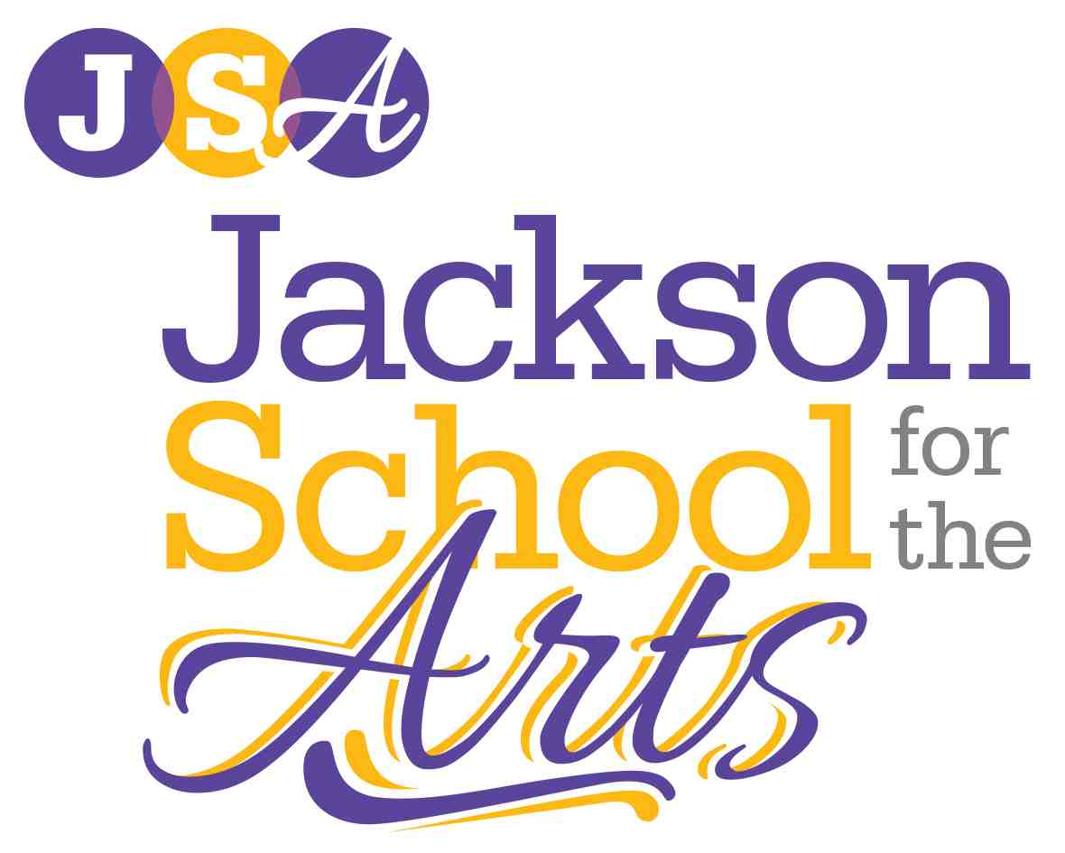

New York Themed 2020 Arts Extravaganza Set for February 22
Showcases 800 Student Artists, Dozens of Live Performances

Massillon, Ohio – February 14, 2020 – The New York themed 2020 JSA All District Arts Extravaganza is set for Saturday, February 22 and doors open at 4:30 p.m. This popular annual community arts showcase will spotlight more than 800 young artists, countless live performances, and impressive student artwork including regional and state award winners.

Live performances include Choir, Chorale, Jacks-N-Jills Show Choir, Ensemble, Edge Dance Company, Jazz Dance, Modern Dance, Ballet, Jazz Band, Steel Drum Band, Big Band, and theatrical performances from Mamma Mia!, Aladdin Jr., Jungle Book Kids and much more.

“The JSA journey began with 20 students, and this year we will welcome more than 350 to the program. This represents more than 2,000 percent growth,” said Director, Susan Gardner. “On this special night, we come together as a community to celebrate the evolution of the JSA program, the talented students we serve and all those that continue to make JSA possible.”

Held at Jackson High School, the event will host the popular Silent and Live Auction featuring more than 150 unique packages and experiences. For event details and to view the latest videos and galleries, visit www.jsajackson.org.

Special thanks to all the generous students, staff, parents and volunteers that make this event and the Jackson School for the Arts possible including more than 15 event sponsors and many generous Patrons of the Arts

About the Jackson School for the Arts
Now serving more than 350 students, the Jackson School for the Arts (JSA) is a 501(c)(3) nonprofit providing a highly specialized arts program within Jackson High School. Established in 2001, JSA provides talented students with unique curriculum including Advanced Placement (AP) and College Credit Plus (CCP) courses, real-world art experiences and activities, and access to student organizations and mentoring. Students are exposed to vocal music, instrumental music, dance, visual art, photography and theatre and are required to meet high academic standards for eligibility and continued program participation. To learn more, visit www.JSAjackson.org, and connect on Facebook.

